Please complete the current document according to the instructions on this page and the Standard Operating Procedure(SOP) Document Templates [MTG-DOC-001].

Template Name
MTG-TPL-033 RWE Manuscript

Version History
Version | Author | Date | Notes | Supported
1.0.0 | Mariana Pais | Feb 10, 2023 | Initial Version | Yes
1.1.0 | Cristina Jácome | Jan 13, 2025 | Descriptions and examples added

Instructions
[...] Indicates a field to fill in with relevant information. Any instructions regarding the field will be written within the field brackets.
{...} Indicates an instruction to consider in the following content blocks. Proceed according to such instruction, then delete the {...} blocks before finalizing the document.

Delete this page and refresh the table of contents before finalizing the document.

[ACRONYM] Manuscript

Title page

Title
{Try to concisely include relevant key terms referring to the study population, objectives, data sources and outcomes. Consider including the study design using terms ‘real-world’ or ‘observational’ in the sub-title. Avoid abbreviations and acronyms unless widely recognized in the field. Ensure that title lengths do not exceed 10 to 15 words.}
[...]

Target Journal
{journal name, IF, quartile}

Authors
{List authors and respective affiliations. Affiliations should be ordered by most to least important. In case a submission does not allow all filiations, keep the top N allowed.}
{Author Name 1}, {academic_degree}, {ORCID …}
{e-mail}
{Filiation description 1}
{Filiation description N}
{Author Name N}, {academic_degree}, {ORCID …}
{e-mail}
{Filiation description 1}
{Filiation description N}
Corresponding author
{Author Name}
{address}
{email}

Instructions

Journal instructions: [link to instructions]

Submission site: [link to submission platform]

Abstract structure: [Structured-Introduction, Methods, Results, Conclusions/Unstructured]

Abstract maximum word count: [xx characters including spaces/xx words]
Manuscript maximum word count: [xx words]

References style: Vancouver

Tables/Figures allowed: [x tables/x figures maximum]

Additional information: {Add below any additional information considered relevant}

Abstract
Typically an abstract has between 250-350 words. Write sub-sections according to the instructions provided in the template MTG-TPL-034 RWE Abstract. Ensure that all sub-sections are balanced in length, even if the journal uses unstructured abstracts. Limit the use of abbreviations and avoid citations or references.}

Introduction

Methods

Results

Conclusion

Keywords
{Select 3 to 5 concise keywords that best represent the core aspects of the research work. Begin by consulting the Medical Subject Headings (MeSH) database to identify standardized terms related to the research. Ensure that none of the keywords are duplicated from the title of the manuscript.}

Introduction
{Introduce the general area of research and why it is important. Summarize key studies or findings that relate to the research, using recent evidence (preferably from the last 5 years and systematic reviews when available). Highlight gaps or unresolved questions in the existing literature that the study aims to address. Ensure a logical sequence between paragraphs.
Conclude this section by stating the study objectives. Ensure that aims provided in the Abstract and in the Introduction section are as similar as possible to avoid misunderstandings. The rationale for these aims should have been clearly articulated in the previous paragraphs, as no new information should be provided at this stage. Aim for a length of approximately one to one and a half pages.}
Example:
Opening sentence: Broad statement about the field, “[Disease] is a major worldwide health concern and has been the subject of numerous research efforts and public health strategies in recent decades [1]. Based on the most recent information from the World Health Organization (WHO), [disease] ranks as the top global death cause, accounting for over a third of total deaths[2]. [Disease] contributes significantly to disability-adjusted life years and premature deaths globally[3]. In Portugal, [disease] affects [prevalence] of individuals and is more prevalent in [subgroup].
Literature review: Key studies and gaps. “Despite being a highly prevalent condition, evidence of [aspect of interest] is relatively scarce in the [population of interest].”
Study objective: What you aim to achieve, “In this study, we aimed to [...]/The aim of this study was [...]”

Methods

Study design
{Introduce in the first sentence the study design. Characterize the Institution in terms of degree of differentiation and number of served population. Explain the data sources and the specific time period analysed. If the journal does not have a designated section for ethical considerations, include a sentence regarding ethical approval. Mention the name of the ethics committee, the project reference number/approval date, and clarify that informed consent was waived, along with a brief justification for this waiver. State the reporting guideline adopted for the study to ensure adherence to standards in research reporting. The most commonly used are STROBE for observational studies; STaRT-RWE for RWE studies of the safety and effectiveness of treatments; GROW for oncology RWE; and checklist for healthcare database studies.}
Example:
“This is an observational retrospective cohort study using electronic health records (EHR) from the [Institution], a healthcare institution comprising [...] primary care centres and one hospital that provides secondary and tertiary care services in the [...] region in [...]. The study used EHR of adults treated at [...] between [Month Day, Year] and [Month Day, Year].
All methods were performed in accordance with the ethical guidelines for human participants. The Ethical Committee [...] and the Data Protection Officer of the [Institution] approved the study [approval reference/date] and waived the requirement for informed consent due to the retrospective nature of the study. This study was reported following the recommendations [reporting_guideline].”

Study Population
{Present the inclusion and exclusion criteria for study participants. If no exclusion criteria are defined, explicitly state this rather than omitting. Whenever possible, state the representativeness of the study population, in relation to the source population (e.g., based on the most recent Census). Specify the index date and had a study design diagram using the framework outlined in Schneeweiss et al (find some examples here).}
Example:
“The index date was defined as the first time [...] (Figure x). In order for a patient to be included in the study, the following criteria had to be met at the same point in time: i) age between [...] years; ii) at least [...] appointment with a primary care physician in the [...] years preceding the index date; iii) at least [...] record in the last [...] year before the index date. The exclusion criteria were: [...]./The study does not have any additional exclusion criteria. These eligibility criteria maximize the overlap of the study population with the resident population, which we believe to account for approximately [...] of the resident population of [...], according to the [Year] Portuguese Census.”
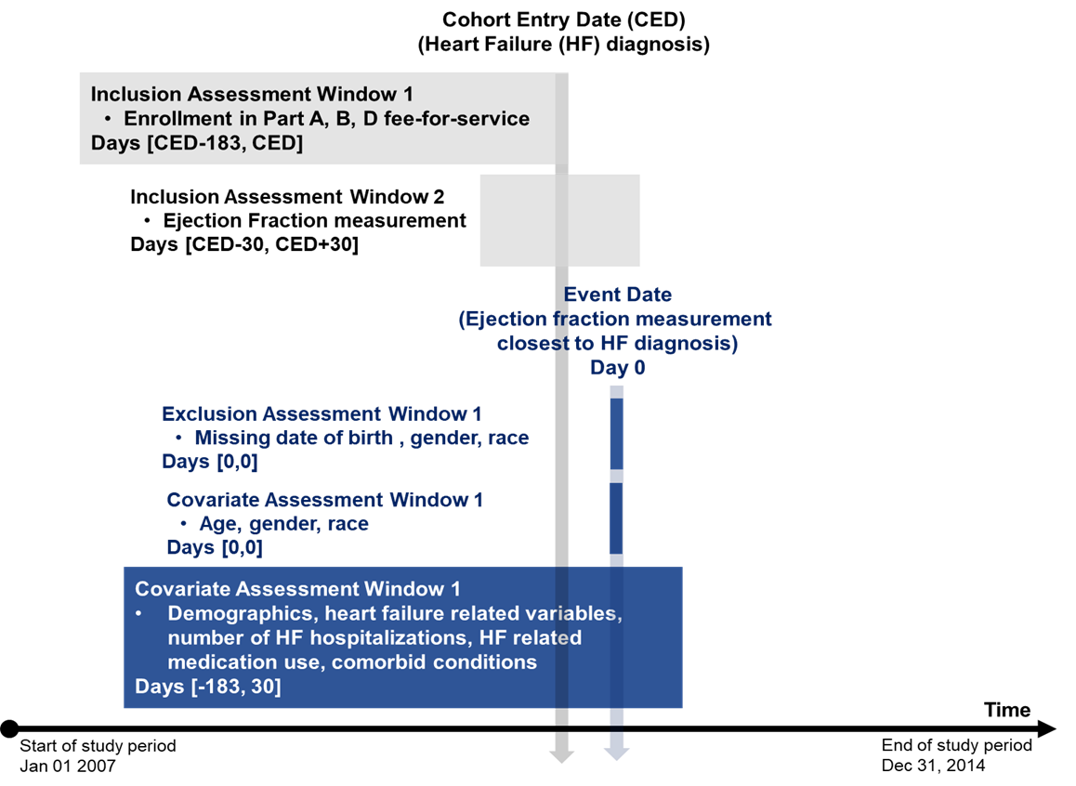
Figure 1: Study diagram for predicting ejection fraction values or class. Abbreviations: HF, heart failure; CED, cohort Entry Date.

Exposure/Cohort
{Clearly identify what constitutes the exposure in the study (e.g., specific treatment, intervention, risk factor) and how the exposure was measured. If applicable, categorize the exposure into relevant groups/cohorts (e.g., if study involves medication, specify groups such as "high dose," "low dose," and "no treatment”). Specify the time period during which exposure was assessed. Detail whether exposure was measured at a single point in time, over a range of dates, or cumulatively. If relevant, mention how the timing relates to the outcome assessment.}
Example:
“Exposure was defined as any time point in which [...]. [xx] cohorts were defined based on [...]”
“The [...] cohort only included patients with [...]”

Outcome(s)/Endpoint(s)
Define outcome(s) or endpoint(s) (e.g., hospitalizations, survival rates, symptom reduction), state any criteria or definitions used to classify outcome (e.g., based on an international classification); how the outcome was measured, specify the time points at which outcome was assessed.}
Example:
“Evaluated outcomes included [list outcomes of interest].”
“The outcomes evaluated were [outcome(s)] at [time points].”
“We defined the achievement of the [outcome] after exposure as [...]./[Oucome] was defined as a [...] and coded using ICD-9 [...] or ICD-10 [...].”
“[Outcome] category was computed according to the current version of the [...] Guidelines.”

Covariates
{Covariates are variables that may influence the outcome and are included in the analysis to control for their effects. Define covariates used in the study (e.g., age, sex, comorbidities, socioeconomic status, and lifestyle factors) and how they were assessed (e.g., "BMI was calculated using weight and height measurements from EHR"). Explain the rationale for selecting each covariate.}
Example:
“The patient’s age and sex were determined from the administrative record available in the EHR due to their established association with [disease/outcome]. The presence of other health conditions was defined using the most comprehensive and granular records available, which included: i) visit and diagnosis data, which were coded using International Classification of Primary Care, 2nd Edition (ICPC-2), International Classification of Disease, 9th Revision (ICD-9), and International Classification of Disease, 10th Revision (ICD-10) codes; ii) laboratory and clinical measurements, coded using ad-hoc vocabularies that were standardised to the systematised nomenclature of medicine clinical terms (SNOMED CT); iii) prescribed medications, coded using the ATC Classification System; and iv) free-text clinical notes from both primary and secondary care. A detailed definition of these variables is shown in Supplementary Table Sx.”

Data processing
{Provide a brief overview of the data processing framework - how data processing data remained secure and compliant with ethical guidelines (e.g., local execution, trusted research environment). Describe the data source used for the study, explaining that it is stored in the Institution(s) data lakehouse; and includes a comprehensive copy of Electronic Health Records (EHR) formatted according to a standardized model. Describe the study package data engineering pipeline. Specify the statistical software and versions used during these steps.}
Example:
“[Institution(s)] maintains a data lakehouse that contains a complete copy of all EHR records structurally formatted according to Observational Medical Outcomes Partnership (OMOP) Common Data Model (CDM) version 5.4. Data processing was performed using an algorithm-goes-to-data approach that removes the need to share patient-level data with researchers. This means that all relevant data processing steps were developed prior to data processing and made available in a study package for [Institution(s)] to execute locally in a Trusted research environment. The study package for this study was developed using SIGIL Scientific Enterprises Vero Framework, and was compiled for [Institution(s)] infrastructure based on Apache Trino 466. The study package implemented the complete data engineering pipeline to transform the source data into the final dataset,to process data in OMOP-CDM format as well as execution of statistical analysis and generation aggregate results reports in tabular format.”

Statistical Analysis
{}
Example:
Descriptive statistics were used to present the global characteristics of the study population. Sub-analyses were performed by [cohorts, outcome category]. The continuous variables were reported as the median (P50), 25th percentile (P25) and 75th percentile (P75). Categorical variables were presented as absolute and relative frequencies. Logistic regression models were fitted to estimate the odds ratios for [outcome] associated with the [exposure], adjusting for [covariates]. To estimate the risk for [outcome], we used a Cox proportional hazards model adjusted at baseline for [covariates]. We used R version 4.3.2 to perform the statistical analysis and Vega-lite to generate figures. A significance level of p < 0.05 was used.

Results
{The obtained results are typically represented in tables and/or graphs. This section does not aim to report all the results described in the tables and/or graphs, but rather to summarize them, highlighting the most important findings. The presentation of the results should be done without including any interpretation/discussion.}

Patient characteristics/Study Population
{Begin by presenting descriptive statistics for the study population. Include demographic information (e.g., age, sex, comorbidities) and baseline characteristics.
Add a table to summarize this information and refer to this table in the text. This is usually the first table of the paper. It is meant to show all relevant cohort characteristics, and should include any characteristics that are used in formulas as well. Do not forget to standardize decimal places, present variables in the same order they appeared in the Methods section, include units, define abbreviations used and avoid vertical lines.}
Example:
The demographic and clinical characteristics of the total cohort are shown in Table 1. Most patients were [sex with higher frequency] and had a median (P25-P75) age of xx(xx-xx) years.
Table 1: Baseline cohort characteristics (n=544).
Patient Characteristics | Total  n=544 | Male  n=380 | Female  n=164
Female, n (%) | 164 (30.1) | - | -
Age (years) | 65 (50-67) | 63 (49-65) | 68 (55-71)
LDL-C (mg/dL) | 116 (71-120) | 116 (70-125) | 113 (65-130)
LDL-C Controlled, n (%) | 191 (35.1) | 134 (35.3) | 57 (34.8)
Data shown as P50 (P25-P75) unless otherwise indicated. Abbreviations: LDL-C, Low density lipoprotein - cholesterol.

[Outcome(s)]
{Report the results of inferential statistical tests conducted (e.g., p-values, confidence intervals, effect sizes). If applicable, include results for subgroup analyses and results from adjusted analyses (e.g., regression models), highlighting how covariates impacted the outcomes. Use tables and figures to present complex data visually.}
Example:
"The results indicated that exposure to [...] was associated with a significant reduction in risk (adjusted odds ratio xx, 95% CI xx–xx)."
"In subgroup analyses, older participants demonstrated an even greater effect (adjusted OR xx, 95% CI xx–xx)."
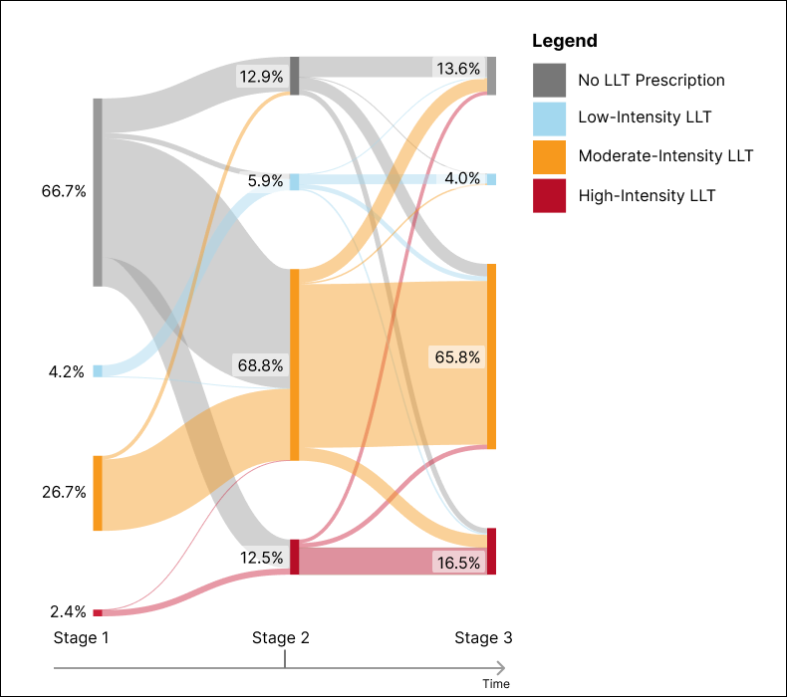
Figure 1: Proportion of patients in each Lipid-Lowering Therapy (LLT) intensity level through the three stages. Stage 1- period of 365 days before the index date; Stage 2- period of 7 days before and 7 days after the index date; Stage 3- one year (365+30 days) after index date. Index date: non-fatal ACS event between 01-01-2016 and 31-12-2022.
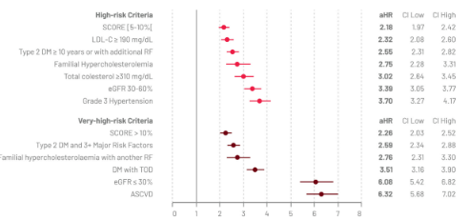
Figure 2: Adjusted 10-year hazard ratios (aHR) of high and very-high cardiovascular (CV) risk criteria for CV death or hospitalization for ASCVD. Notes: ASCVD, atherosclerotic cardiovascular disease; CI, confidence interval; DM, diabetes mellitus; eGRF, estimated glomerular filtration rate; LDL-C, low density lipoprotein cholesterol; RF, risk factors; SCORE, systematic coronary risk evaluation system; TOD, target organ damage.
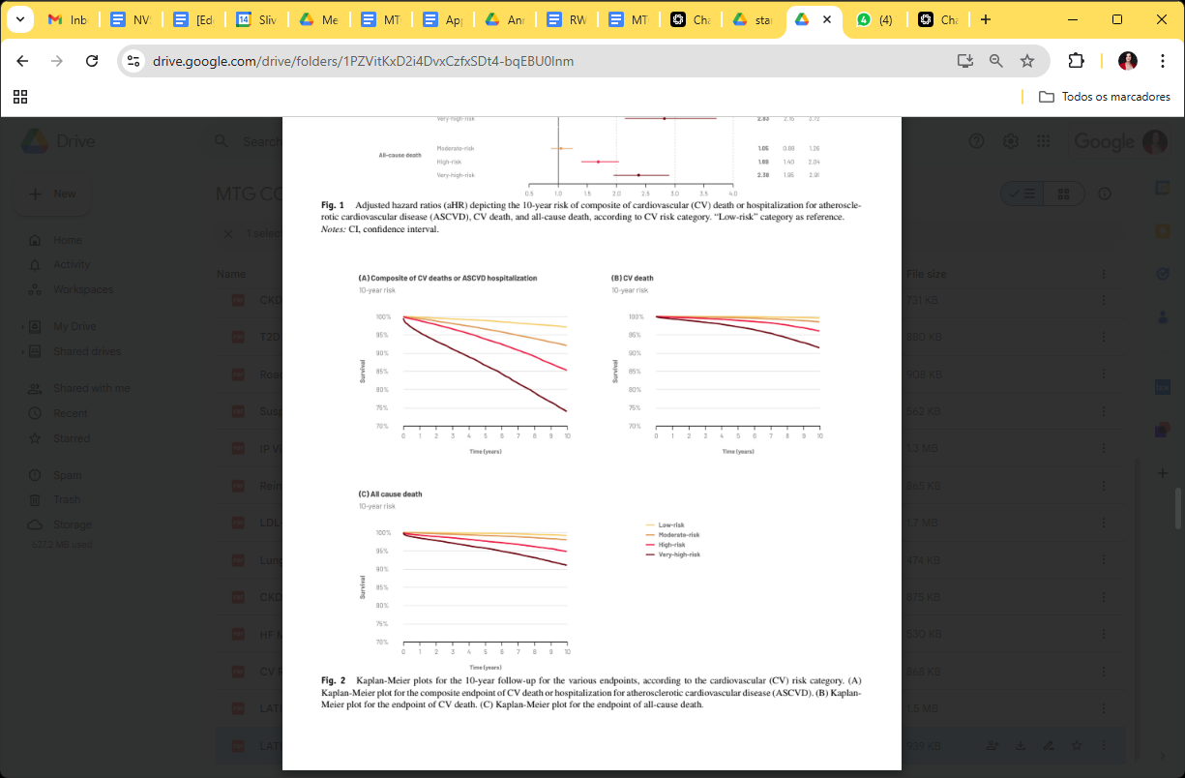
Figure 3: Kaplan-Meier plots for the 10-year follow-up for the various endpoints, according to the cardiovascular (CV) risk category. (A) Kaplan-Meier plot for the composite endpoint of CV death or hospitalization for atherosclerotic cardiovascular disease (ASCVD). (B) Kaplan-Meier plot for the endpoint of CV death. (C) Kaplan-Meier plot for the endpoint of all-cause death.

Discussion
{The first paragraph of the Discussion should briefly state the main findings of the study. Make sure to tie findings back to the study aim.
Dedicate 3-5 paragraphs into following topics:
Discuss what the findings mean in the context of the research questions and objectives. Consider the implications for the field and how they contribute to existing knowledge.
Compare findings with previous studies and literature. Discuss similarities and differences, and provide insights into how study supports, contradicts, or builds upon existing research. When contradicting previous evidence, explain reasons for differences (study population differences, organization factors - medical specialty).
Identify missed opportunities and explain why they exist and how can they be solved (e.g., access inequalities, COVID-19 limitations, guideline awareness).
Dedicate one paragraph to acknowledge the limitations of the study, while trying to highlight its strengths. Discuss how limitations might affect the interpretation of the results and their generalization. Describe the strategies used to overcome or mitigate the effects of these limitations and suggest areas for future research.}

Conclusion
{In the final paragraph, summarize the main findings and their significance. Discuss the implications of findings for clinical practice, public health/policy, or future research, highlighting their relevance.}
Example:
"We demonstrated/found that [...].”
“These results/findings suggest/indicate that [...], underscoring the importance of [...].”
“Our study reinforces the relevance of [...], highlighting implications for [...].”
“Future studies should further investigate the [...].”

References
{Commonly around 30. Avoid using references from abstracts published in conferences. Ensure that reference formatting aligns with the chosen citation style of the journal. Confirm that references to digital reports/websites include the URLs along with the date of access. Check for any omissions regarding the volume number or page range in scientific papers, as these are crucial for proper citation.}

Supplementary material
{Additional data, methods, figures/videos, tables, or detailed analyses that support the main manuscript but are too lengthy or detailed to include in the main text. Ensure that the supplementary materials are appropriately referenced within the main manuscript (e.g., "See Supplementary File 1 for additional data."). Review and proofread the supplementary file thoroughly as these materials are commonly not included in the peer-review process nor checked at proofs stage.}

Disclosures

Acknowledgments
{The Acknowledgments section is intended to express gratitude to individuals and organizations that contributed to the research but do not qualify for authorship.}
Example:
“The authors would like to acknowledge {the editorial support, namely the constructive review of the manuscript and raised comments/[Person] from SIGIL Scientific Enterprises for providing technical support in analysis implementation. The authors also would like to acknowledge [institution name] for granting permissions for this study and to [name of IT staff] from the Department of Information Technologies for supporting data processing.”

Compliance with ethical standards
Example:
“This study was approved by the local Ethic Committee from [Institution name (approval reference)]. Due to the retrospective nature of the study, informed consent was not obtained.”

Conflicts of interest
{The Conflicts of Interest section aims to disclose any potential biases or competing interests that could influence the research or its interpretation. Read the International Committee of Medical Journal Editors recommendations for more info. Some journals require that each author submit the ICMJE disclosure form.}
Example:
“[x.x.] declares speaker and consulting fees from [...]. [x.x.] and [x.x.] are employees of [...].”

Funding
{State the names of the organizations, institutions, or agencies that provided funding. Include specific grant numbers if applicable.}
Example:
“This study was funded by [...].”

Author’s Contributions
{Consider these main responsibilities and add authors initials to each:
- Conceptualization: Developing the research idea or framework.
- Methodology: Designing the methodology and approach to carry out the research.
- Formal Analysis: Applying statistical or analytical methods to project data.
- Writing - Original Draft: Writing the initial draft of the manuscript. Commonly the first author.
- Writing - Review & Editing: Reviewing and revising the manuscript for content and clarity. All authors need to have this role
- Project management.}
Example:
“Conceptualization, C.G., D.S.C., M.A.-S., T.T.-G. and F.A.; Methodology, C.G., N.L.-S. and T.T.-G.; Formal analysis, N.L.-S. and T.T.-G.; Writing - Original Draft, N.L-S.; Writing - Review & Editing, C.G., D.S.C., M.A.-S., I.C., A.S.F, M.C.-P., N.L-S., T.T.-G and F.A.”

Data Availability Statement
{The Data Availability Statement informs readers about the accessibility of the data associated with the research, promoting transparency and reproducibility.}
Example:
All aggregate statistical results are incorporated into the article and its online supplementary material. Patient level data used in this study is not publicly available for ethical reasons/to maintain participant confidentiality/due to privacy constraints .

